**Classroom Activity: Create a New React Application**

**Step 1:**

**Create a Workspace Folder**

* Open a terminal or command prompt.
* Navigate to the location where you want to create your new project.
* Create a new folder for your workspace:

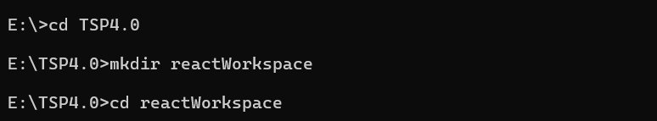

Figure: Workspace Folder

**Step 2:**

**Open Workspace with VS Code**

* If you have Visual Studio Code installed, you can open the folder directly from the terminal:



Figure: Opening Folder in VS Code

* Alternatively, you can open VS Code, then go to File > Open Folder... and select your **reactWorkspace** folder.

**Step 3:**

**Create a New React Application**

* In the VS Code terminal, run the following command to create a new React application:

*npx create-react-app my-first-app*

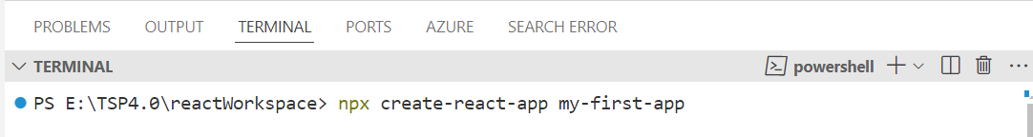

Figure: How to run command for creating react application.

**Step 4:**

**Change Directory to Your Project:**

* In the VS Code terminal, navigate to the newly created project folder:



Figure: How to change Directory to Project*.*

**Step 5:**

**Start the Development Server:**

* In the VS Code terminal, start the development server using npm start command to view your application in the browser:

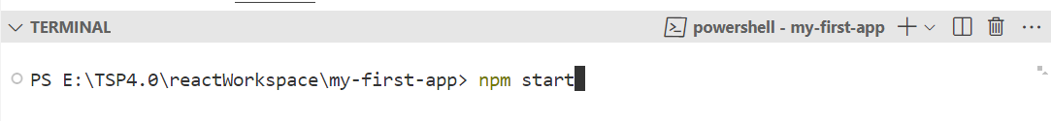

Figure: How to start the Development Server*.*

* This will open your default browser and navigate to **http://localhost:3000**, where you will see your new React application running.

**Step 6:**

**Explore the Project Structure:**

* In the VS Code Explorer pane, you can see the structure of your React application:

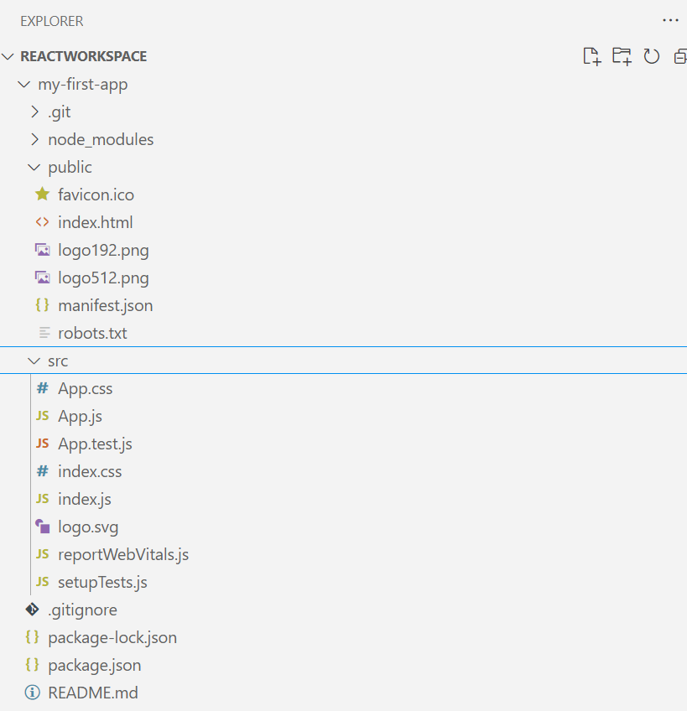

Figure: Project Structure*.*